Face Recognition with Attendance System

***Internship report Submitted in fulfilment of the requirements for the degree***

***of***

## Bachelor of Technology

***By***

**Pradyumna Kumar Mohapatra Registration Number: 2201109i52**

**Branch: Computer Science and Engineering**

**Semester: 5th Section: A**



*Submitted to*

**Department of Computer Science and Engineering Parala Maharaja Engineering College Berhampur**

**(**AFFLIATED TO BIJU PATNAIK UNIVERSITY OF TECHNOLOGY**)**

(June 2025 – July 2025)



**DEPARTMENT OF COMPUTER SCIENCE AND ENGINEERING**

**PARALA MAHARAJA ENGINEERING COLLEGE**

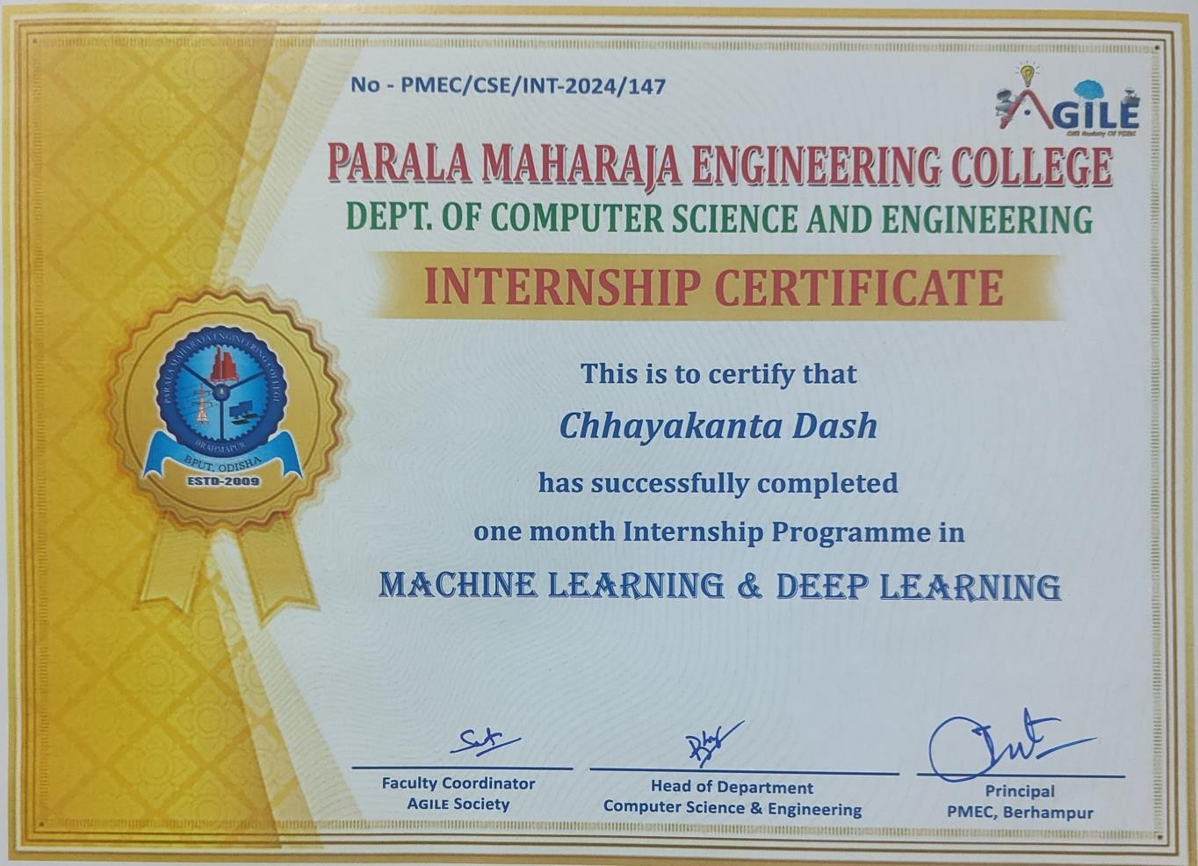

# DECLARATION

I hereby certify that the work which is being presented in the report entitled *“****Face Recognition with Attendance System****”* in partial fulfilment of the requirements for the award of the Degree of Bachelor of Technology and submitted to the Department of Computer Science and Engineering, Parala Maharaja Engineering College, Sitalapalli, Berhampur, Odisha, is an authentic record of my own work carried out during the Academic Session 2025.

The project was completed as part of my **AI & ML Summer internship at Central Tool Room & Training Centre (CTTC), Bhubaneswar,** under the Ministry of MSME, Govt. of India. The matter presented in this report has not been submitted by me for the award of any other degree of this or any other Institute/University.

Chhayakanta Dash

# ACKNOWLEDGEMENT

At the very outset, I would like to express my sincere gratitude to the **Principal, Parala Maharaja Engineering College, Berhampur**, for permitting me to carry out my internship and submit this project report entitled ***“Face Recognition with Attendance System.”***

I extend my heartfelt thanks to the **Central Tool Room & Training Centre (CTTC), Bhubaneswar,** Ministry of MSME, Govt. of India, for providing me with the opportunity to undergo internship training in **“Artificial Intelligence & Machine Learning”**.

I am especially grateful to my mentors and coordinators at CTTC for their constant support, guidance, and valuable insights during my training period. I would also like to thank the faculty members of the **Department of Computer Science & Engineering, PMEC**, for their motivation and encouragement throughout this project.

Finally, I acknowledge with gratitude the support of my classmates, friends, and family who directly or indirectly helped me in the successful completion of this project.

Chhayakanta Dash 2201109032

# ABSTRACT

Face recognition has emerged as one of the most widely used applications of Artificial Intelligence (AI) and Machine Learning (ML), particularly in the domain of security and automation. This project, *“Face Recognition with Attendance System”*, focuses on automating the process of recording attendance using computer vision and deep learning techniques.

The system employs **Haarcascade Classifier** for face detection and **Convolutional Neural Networks (CNN)** for feature extraction and recognition. Each detected face is matched with pre-trained images in the dataset, and upon successful recognition, the student’s attendance is marked automatically in a database or spreadsheet along with date and time.

Python libraries such as **OpenCV, NumPy, Pandas, and Matplotlib** are utilized for implementation, while CSV/Excel sheets are used for attendance storage. The system has been tested under various conditions, including changes in lighting, angles, and expressions, and demonstrates reliable accuracy for real-time use.

This project showcases the integration of **Computer Vision, Deep Learning, and Data Handling** to solve a practical problem of manual attendance, reducing human error, saving time, and providing a secure and efficient alternative for educational institutions and organizations.

Table of Contents

**ACKNOWLEDGEMENT** ............................................................................................................... I

**ABSTRACT** ................................................................................................................................ II

**CHAPTER 1 – INTRODUCTION** ............................................................................................ 1  
1.1 Artificial Intelligence and Machine Learning ....................................................................... 1  
1.2 Traditional Programming vs. Machine Learning .................................................................. 2  
1.3 Types of Machine Learning .................................................................................................. 2  
1.4 Deep Learning Overview ...................................................................................................... 3  
1.5 Applications of AI & ML ..................................................................................................... 4

**CHAPTER 2 – PYTHON FUNDAMENTALS FOR AI & ML** ................................................... 5  
2.1 Python Basics ......................................................................................................................... 5  
2.2 Data Structures: List, Dictionary, Tuple ............................................................................... 6  
2.3 Control Structures (If-Else, Loops) ....................................................................................... 7  
2.4 Functions and Object-Oriented Programming ...................................................................... 8

**CHAPTER 3 – PYTHON PACKAGES FOR MACHINE LEARNING** ....................................... 9  
3.1 NumPy .................................................................................................................................... 9  
3.2 Pandas and Data Cleaning .................................................................................................... 10  
3.3 Matplotlib ............................................................................................................................. 11  
3.4 Seaborn ................................................................................................................................. 12

**CHAPTER 4 – SUPERVISED LEARNING** ............................................................................. 13  
4.1 Linear Regression ................................................................................................................ 14  
4.2 Logistic Regression ............................................................................................................. 15  
4.3 Decision Trees ...................................................................................................................... 16  
4.4 Support Vector Machines (SVM) ....................................................................................... 17  
4.5 K-Nearest Neighbour (KNN) .............................................................................................. 18  
4.6 Naïve Bayes ......................................................................................................................... 19  
4.7 Evaluation Metrics (Accuracy, Precision, Recall, F1 Score) .............................................. 20

**CHAPTER 5 – UNSUPERVISED LEARNING** ........................................................................ 21  
5.1 Clustering (K-Means, Hierarchical, DBSCAN) ................................................................... 22  
5.2 Dimensionality Reduction (PCA, SVD) ............................................................................. 23  
5.3 Applications of Unsupervised Learning .............................................................................. 24

**CHAPTER 6 – NATURAL LANGUAGE PROCESSING (NLP)** .............................................. 25  
6.1 Introduction to NLP ............................................................................................................. 25  
6.2 Text Preprocessing and Tokenization .................................................................................. 26  
6.3 Sentiment Analysis using TextBlob .................................................................................... 27  
6.4 Case Studies .......................................................................................................................... 28

**CHAPTER 7 – COMPUTER VISION & DEEP LEARNING** ................................................... 29  
7.1 Introduction to Computer Vision ......................................................................................... 29  
7.2 Image Processing (Blurring, Edge Detection) .................................................................... 30  
7.3 Convolutional Neural Networks (CNN) ............................................................................. 31  
7.4 CNN Architecture (Convolution, Pooling, Fully Connected) ............................................ 32  
7.5 Applications of CNN in Image Recognition ....................................................................... 33

**CHAPTER 8 – PROJECT: FACE RECOGNITION WITH ATTENDANCE SYSTEM** ............ 34  
8.1 About Dataset ...................................................................................................................... 34  
8.2 Face Detection (Haarcascade Classifier) ............................................................................. 35  
8.3 Face Recognition (LBPH and CNN) .................................................................................. 36  
8.4 Attendance System Implementation .................................................................................. 37  
8.5 Testing and Results .............................................................................................................. 38

**CHAPTER 9 – FUTURE WORK** ............................................................................................. 39

**CHAPTER 10 – ADVANTAGES & DISADVANTAGES** ......................................................... 40

**CHAPTER 11 – CONCLUSION** ............................................................................................. 41

**REFERENCES** ......................................................................................................................... 42

### LIST OF FIGURES

**Figure 1** : Machine Learning & Deep Learning ....................................................................... 1  
**Figure 2** : Types of Machine Learning ..................................................................................... 2  
**Figure 3** : Data Pre-processing ................................................................................................. 3  
**Figure 4** : Supervised Learning ................................................................................................ 6  
**Figure 5** : Decision Tree Example............................................................................................ 9  
**Figure 6** : Linear vs Logistic Regression................................................................................. 11  
**Figure 7** : K-Nearest Neighbor (KNN) .................................................................................. 12  
**Figure 8** : Naïve Bayes Classifier .......................................................................................... 13  
**Figure 9** : Unsupervised Learning ......................................................................................... 14  
**Figure 10** : K-Means Clustering ............................................................................................ 15  
**Figure 11** : DBSCAN Clustering ........................................................................................... 15  
**Figure 12** : Artificial Neural Network (ANN) ....................................................................... 18  
**Figure 13** : Convolutional Neural Network (CNN) ............................................................... 19

**Project Work**  
**Figure 14** : CNN Architecture (Convolution, Pooling, Fully Connected Layers) ................. 20  
**Figure 15** : Haarcascade Classifier for Face Detection .......................................................... 35  
**Figure 16** : Face Recognition using LBPH ............................................................................ 36  
**Figure 17** : Flowchart of Face Recognition Attendance System ........................................... 37  
**Figure 18** : Screenshot of Attendance Marked in Excel/CSV ............................................... 38

# INTRODUCTION:

Machine Learning (ML) and Deep Learning (DL) are key components of artificial intelligence (AI) that empower computers to analyse data and make informed decisions. ML focuses on creating algorithms that can detect trends, make predictions, and improve over time with minimal human input. It includes approaches like supervised learning, where models learn from labelled examples, and unsupervised learning, where they discover hidden patterns in unlabelled data. Deep Learning, a specialized area within ML, utilizes multi-layered neural networks to capture intricate patterns in large datasets. DL is particularly successful in areas such as image recognition, speech processing, and natural language understanding, thanks to its ability to automatically learn features from raw inputs. While ML is well-suited for handling structured data, DL shines in processing large quantities of unstructured data, fueling many recent breakthroughs in AI.

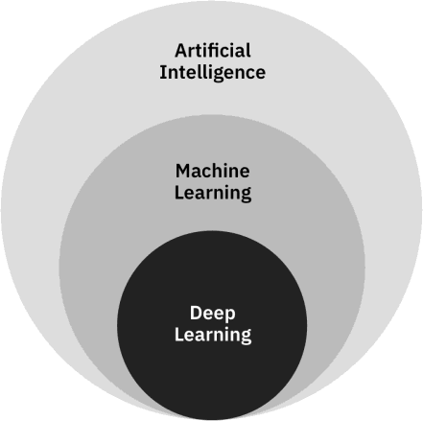

Figure 1: Machine Learning & Deep Learning

## Machine Learning:

Arthur Samuel, an American pioneer in the field of computer gaming and artificial intelligence, coined the term "Machine Learning" in 1959. Over the past two decades Machine Learning has become one of the mainstays of information technology. With the ever-increasing amounts of

data becoming available there is good reason to believe that smart data analysis will become even more pervasive as a necessary ingredient for technological progress.

### Definition of Machine Learning:

ML is a subset of AI that focuses on developing algorithms that allow machines to learn from and adapt to data. It enables systems to improve their performance over time without being explicitly programmed.

### Traditional Programming vs. Machine Learning Approach:

Traditional programming relies on hard-coded rules. Machine Learning relies on learning patterns based on sample data. Machine Learning uses a number of theories and techniques from Data Science.

## Types of Machine Learning:

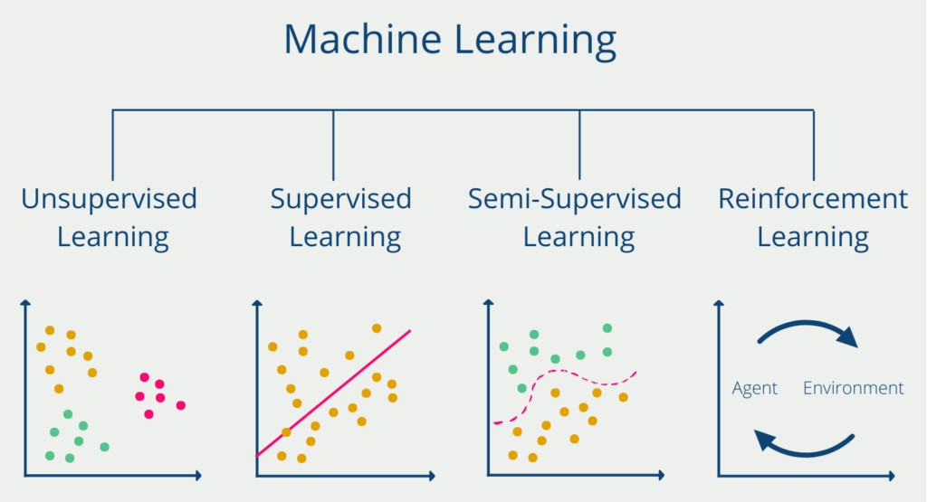

Figure 2: Types of Machine learning

## Data Preprocessing:

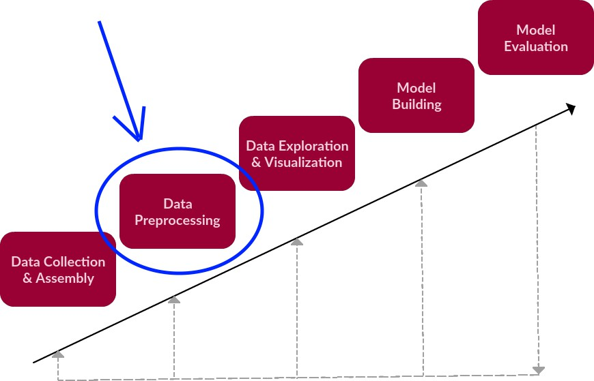

*Figure 3: Data Pre-processing*

### Data objects and attributes:

Data objects are typically described by attributes. The columns correspond to the attributes also known as **features/dimensions/variables** of the data set. Data objects are stored in a database referred as data **tuples/rows/sample**. An attribute can be one of the following types,

* Nominal (Qualitative)
* Binary (Qualitative)
* Ordinal (Qualitative)
* Numeric (Quantitative)

**Nominal** means “relating to names”, the values of a nominal attribute are symbols or names of things.

**A binary** attribute is a nominal attribute with only two categories or states: 0 or 1.

**An ordinal** attribute is an attribute with possible values that have a meaningful ranking among them.

**A numeric** attribute is a measurable quantity, represented in integer or real values.

### Basic Statistical Descriptions of Data

Basic statistics is used to analyse the data set & also helpful in data pre- processing tasks like filling missing values, smoothing of noisy values, spot the outliers present in the data set.

#### Measure of Central Tendency:

The most common and effective numeric measure of the **“centre”** of a set of data is the **(arithmetic) mean**. **The median** is the middle number in a sorted, ascending or descending, list of numbers. **The mode** is the value that appears most often in a set of data values.

* + Mean = (Sum of all values) / (Number of values)
  + Odd number of values: Median = [(n+1)/2]th value (where n is the total number of values). Even number of values: Median = Average of (n/2)th and (n/2 + 1)th values.
  + The mode is simply the value that appears most frequently in the data set.

### Measuring Data Dispersion:

**An outlier** is an observation that lies at an abnormal distance from other values in a random sample from a population. **The range** of the set is the difference between the largest (max()) and smallest (min()) values. **Quantiles** are points taken at regular intervals of a data distribution, dividing it into essentially equal size consecutive sets. The distance i.e. **Interquartile range (IQR) = Q3 − Q1**. **Variance** is a measure of how spread-out numbers are in a data set. **(Variance = Σ(x - μ)² / N) *x*** is each value in the data set ***μ*** is the mean of the data set ***N*** is the number of values in the data set. **Standard deviation** is the square root of the variance. **Standard Deviation = √Variance**.

The **five-number summary** of a data set consists of the five numbers determined by computing the **minimum**, ***Q*1***,* **median***,* ***Q*3***,* and **maximum** of the data set.

### Major Tasks in data preprocessing

#### Data Cleaning:

Process of dealing with incomplete, noisy, and inconsistent data.

#### Dealing with missing value

* + Ignore the tuple: Remove the tuple containing several attributes with missing values.
  + Fill the missing value manually: Fill the missing value manually through observation. In general, this approach is time consuming and may not be feasible given a large data set with many missing values.

#### Dealing with noisy data

* + Binning: Sort the values. Consider a bucket/bin size and fill the bins. Replace the values by bin mean/median/closest boundary.
  + Outlier analysis: Identifying the outliers and removing them. Methods based on IQR, data visualization, clustering can be used for this purpose.
  + Regression: This can also be used for data smoothing. By fitting a linear or nonlinear function.

#### Data Integration:

The merging of data from multiple data stores.

* + **Entity Identification**: How can equivalent real-world entities from multiple data sources be matched up? This is referred to as the entity identification problem.
  + **Duplicate tuple:** Duplication should also be detected at the tuple level. Duplicate tuples should be removed.
  + **Redundancy and correlation analysis:** An attribute may be redundant if it can be “derived” from another attribute or set of attributes.

#### Data Reduction:

Data reduction techniques can be applied to obtain a reduced representation of the data set that is much smaller in volume, yet closely maintains the integrity of the original data.

* + **Numerosity reduction** techniques replace the original data volume by alternative, smaller forms of data representation.
  + **Dimensionality reduction** is the process of reducing the number of variables or attributes under consideration.

# SUPERVISED LEARNING:

Supervised learning is a type of machine learning algorithm that learns from labelled data. Labelled data is data that has been tagged with a classification. Supervised learning, as the name indicates, has the presence of a supervisor as a teacher. Supervised learning is when we teach or train the machine using data that is well-labelled. After that, the machine is provided with a new set of data so that the supervised learning algorithm analyses the training data and produces a correct outcome from labelled data. During training, the model is fed these input-label pairs and makes predictions based on the input data.

These predictions are then compared to the actual labels using a loss function, which quantifies the difference between the predicted and true outputs. The primary goal of the training process is to minimize this loss by adjusting the model's parameters, such as the weights in a neural network, to improve its accuracy in making predictions on new, unseen data.

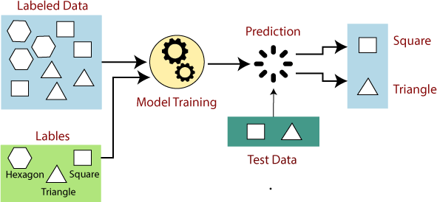

*Figure 4: Supervised Learning*

## Types of Supervised Learning:

Supervised learning is classified into two categories of algorithms:

**Regression:** A regression problem is when the output variable is a real value, such as “dollars” or “weight”.

**Classification:** A classification problem is when the output variable is a category, such as “Red” or “blue”, “disease” or “no disease”.

### Regression:

Regression is a type of supervised learning that is used to predict continuous values, such as house prices, stock prices, or customer churn. Some common regression algorithms include:

* Linear Regression
* Polynomial Regression
* Support Vector Machine Regression
* Decision Tree Regression
* Random Forest Regression

#### Linear Regression:

* + Linear regression is a linear approach for modelling the relationship between a scalar dependent variable y and an independent variable x.
  + The equation is also written as: **y = wx + b,** where b is the bias or the value of output for zero input. Where x, y, w are vectors of real numbers and w is a vector of weight parameters.

#### Multiple Linear Regression:

* + It represents line fitment between multiple inputs and one output, typically:

**y = w1x1+ w2x2 + b**

#### Decision Tree Regression:

* + A decision tree is a graphical representation of all the possible solutions to a decision based on a few conditions.
  + Decision Trees are non-parametric models, which means that the number of parameters is not determined prior to training.

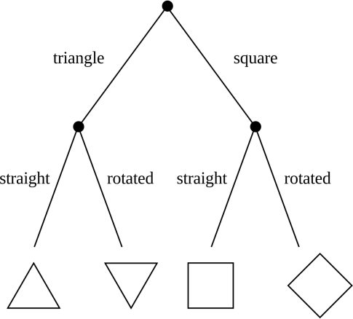

*Figure 5: Decision Tree Regression*

## Evaluating Supervised Learning Models:

#### For Regression:

* **Mean Squared Error (MSE):** MSE measures the average squared difference between the predicted values and the actual values. Lower MSE values indicate better model performance.
* **Root Mean Squared Error:** RMSE is the square root of MSE, representing the standard deviation of the prediction errors. Similar to MSE, lower RMSE values indicate better model performance.
* **Mean Absolute Error:** MAE measures the average absolute difference between the predicted values and the actual values.
* **R-squared (Coefficient of Determination):** R-squared measures the proportion of the variance in the target variable that is explained by the model. Higher R-squared values indicate better model fit.

### Classification:

Classification is a type of supervised learning that is used to predict categorical values, such as whether an email is spam or not or whether a medical image shows a tumour or not. Some common classification algorithms include:

* Logistic Regression
* Support Vector Machines
* Decision Trees
* Random Forests
* Naive Baye

#### Logistic Regression:

* + A binary dependent variable can have only two values, like 0 or 1, win or lose, pass or fail, healthy or sick, etc.
  + The probability in the logistic regression is often represented by the Sigmoid function (also called the logistic function or the S-curve).

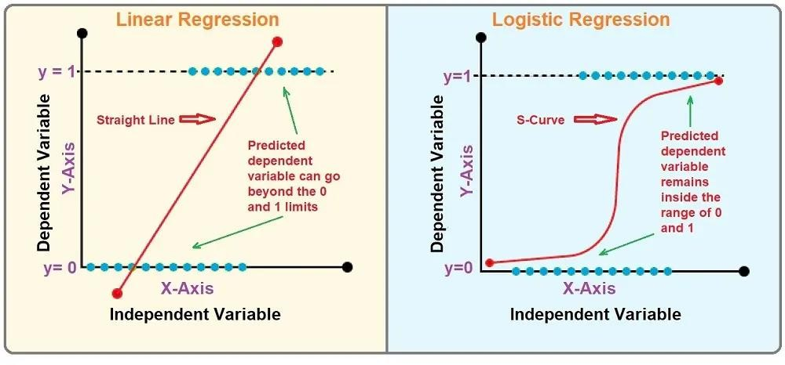

*Figure 6: Linear Regression VS Logistic Regression*

#### Support Vector machines:

* + It can classify both linear and non-linear data. It uses a nonlinear mapping to transform the original training data into a higher dimension. Within this new dimension, it searches for the linear optimal separating hyperplane (i.e., a “decision boundary” separating the tuples of one class from another).
  + The SVM finds this hyperplane using support vectors (“essential” training tuples) and margins (defined by the support vectors).

#### K-Nearest Neighbor’s (KNN):

* + The K-Nearest Neighbors (KNN) algorithm is a simple and intuitive machine learning method used for both classification and regression tasks. It works by comparing a new data point to the nearest data points in the training set, based on a distance metric (usually Euclidean distance). In classification, the new data point is assigned the label that is most common among its "k" nearest neighbors. In regression, the algorithm predicts the value by averaging the values of the nearest neighbors.

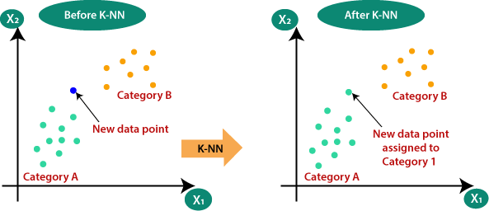

*Figure 7: KNN*

#### Naive Bayes:

* + According to Bayes model, the conditional probability P(Y|X) can be calculated as:

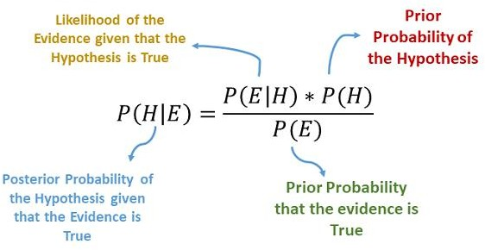

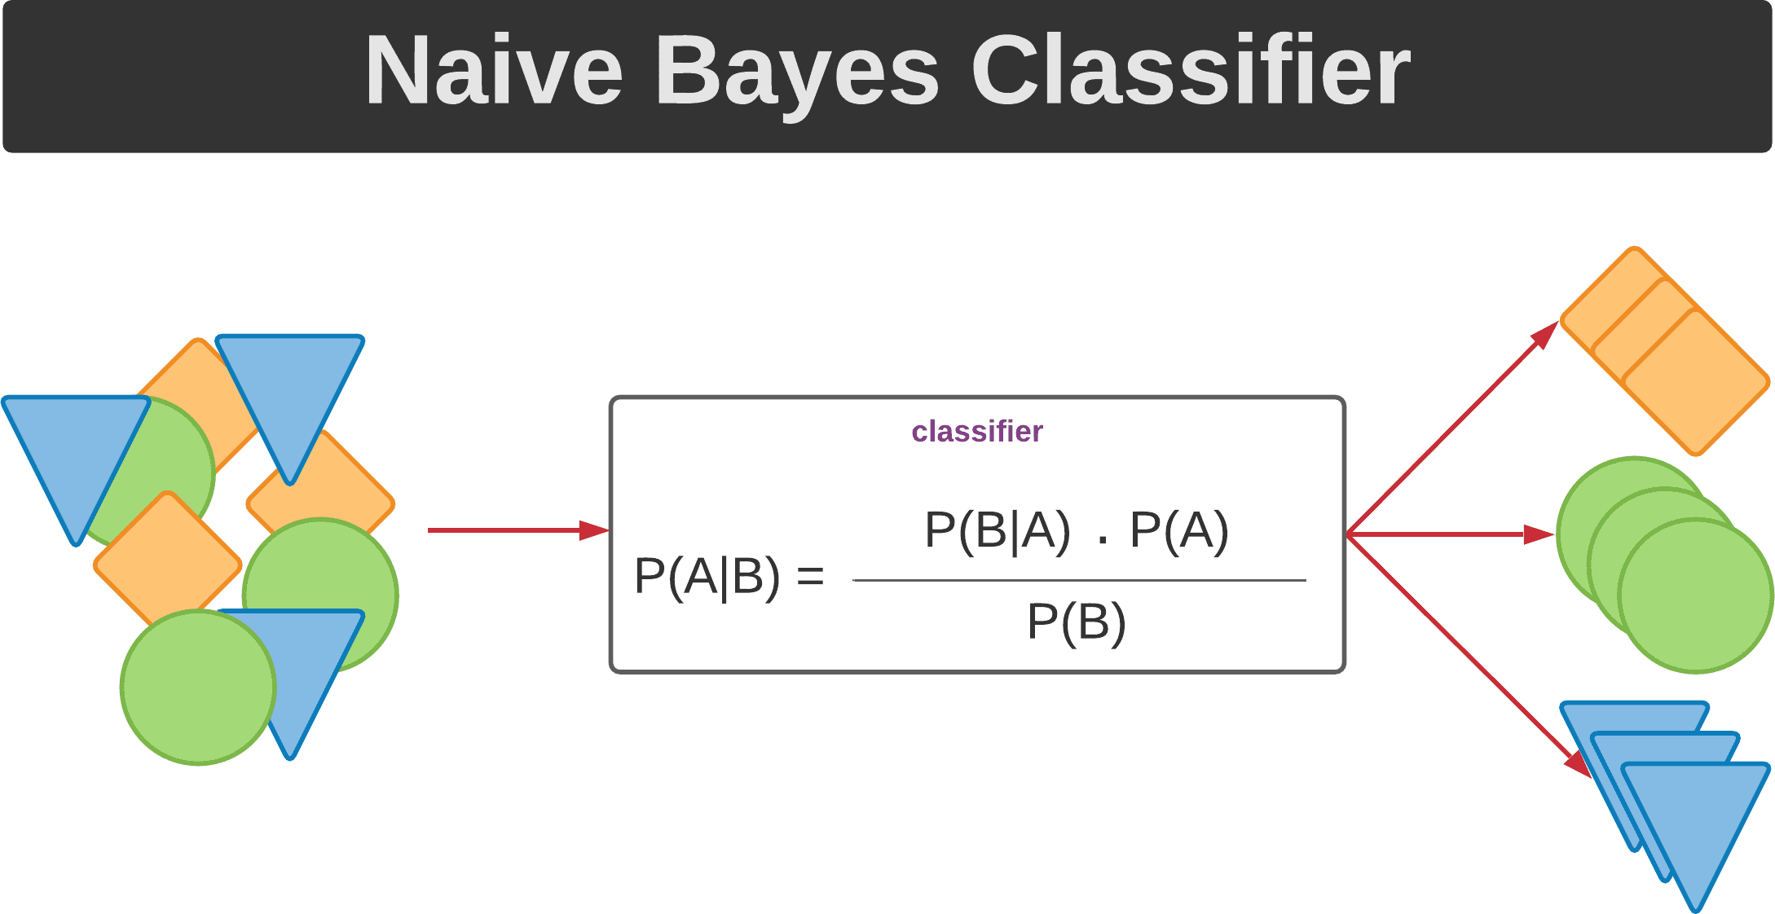

*Figure 8: Naive Bayes Classifier*

#### Decision Tree Classification:

* + The advantage of decision trees is that they require very little data preparation. They do not require feature scaling or centring at all.
  + Start at the tree root and split the data on the feature using the decision algorithm, resulting in the largest information gain (IG).

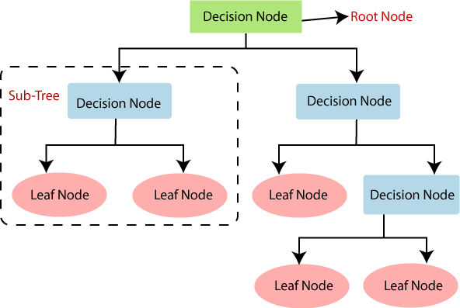

*Figure 9: Decision Tree*

## Evaluating Supervised Learning Models:

### For Classification:

* + **Accuracy:** Accuracy is the percentage of predictions that the model makes correctly. It is calculated by dividing the number of correct predictions by the total number of predictions.
  + **Precision:** Precision is the percentage of positive predictions that the model makes that are actually correct. It is calculated by dividing the number of true positives by the total number of positive predictions.
  + **Recall:** Recall is the percentage of all positive examples that the model correctly identifies. It is calculated by dividing the number of true positives by the total number of positive examples.
  + **F1 score:** The F1 score is a weighted average of precision and recall. It is calculated by taking the harmonic mean of precision and recall.
  + **Confusion matrix:** A confusion matrix is a table that shows the number of predictions for each class, along with the actual class labels

# UNSUPERVISED LEARNING:

As the name suggests, it is opposite to supervised ML methods or algorithms which means in unsupervised machine learning algorithms we do not have any supervisor to provide any sort of guidance. Unsupervised learning algorithms are handy in the scenario in which we do not have the liberty, like in supervised learning algorithms.

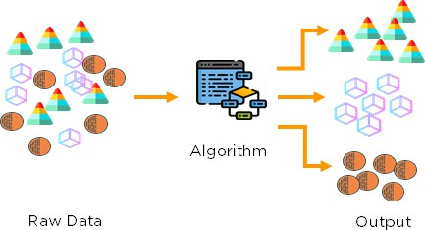

*Figure 10: Unsupervised learning*

Here the task of the machine is to group unsorted information according to similarities, patterns, and differences without any prior training of data. The machine is restricted to find the hidden structure in unlabeled data by itself.

## Types of Unsupervised Learning:

Unsupervised learning is classified into two categories of algorithms:

**Clustering:** A clustering problem is where you want to discover the inherent groupings in the data, such as grouping customers by purchasing behaviour.

**Association:** An association rule learning problem is where you want to discover rules that describe large portions of your data, such as people that buy X also tend to buy Y.

### Clustering:

Clustering is a type of unsupervised learning that is used to group similar data points together. Clustering algorithms work by iteratively moving data points closer to their cluster centres and further away from data points in other clusters.

Clustering Types:

* Hierarchical clustering
* K-means clustering
* Principal Component Analysis
* Singular Value Decomposition
* Independent Component Analysis
* Gaussian Mixture Models (GMMs)
* Density-Based Spatial Clustering of Applications with Noise (DBSCAN)

#### Hierarchical Clustering:

Hierarchical clustering is a method of cluster analysis which seeks to build a hierarchy of clusters. Does not require a predefined number of clusters. It is categorized into two types:

#### K-Means Clustering:

K-Means clustering is a partitioning method that divides a dataset into K distinct, non-overlapping clusters based on their feature values.

* The number of clusters, K, must be specified in advance.
* Uses Euclidean distance as the default metric to measure the distance between points.

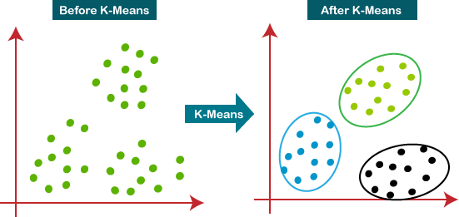

*Figure 11: K-Means Clustering*

#### Density-Based Spatial Clustering of Applications with Noise (DBSCAN):

* DBSCAN is a density-based clustering algorithm that forms clusters based on the density of data points in a region.
* It can find arbitrarily shaped clusters and can handle noise effectively.
* Does not require a predefined number of clusters.
* Defines clusters based on a minimum number of points (minPts) within a given radius (epsilon).
* Identifies core points, border points, and noise points

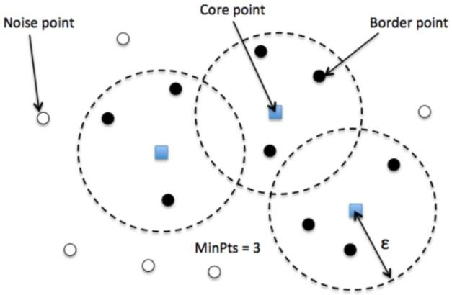

*Figure 12: DBSCAN*

# APPLICATIONS OF MACHINES LEARNING:

Machine Learning is the most rapidly growing technology and according to researchers we are in the golden year of AI and ML. It is used to solve many real-world complex problems which cannot be solved with traditional approach. Followings are some real-world applications of ML:

* Emotion analysis
* Image Recognition.
* Face Recognition
* Sentiment analysis
* Error detection and prevention
* Weather forecasting and prediction
* Stock market analysis and forecasting
* Speech synthesis
* Speech recognition
* Customer segmentation
* Object recognition
* Fraud detection
* Data extraction
* Data learning

# DEEP LEARNING(DL)

Deep learning is a subset of machine learning that uses artificial neural networks with many layers (hence "deep") to model complex patterns and relationships in data. These deep networks can automatically learn and extract features from raw data, making them particularly powerful for tasks like image and speech recognition, natural language processing, and autonomous driving. By stacking multiple layers of neurons, deep learning models can capture intricate patterns at different levels of abstraction, enabling them to outperform traditional machine learning models on large datasets. Deep learning has driven significant advancements in AI, leading to breakthroughs in various fields.

Some Types of Deep Learning:

1. Artificial Neural Network (ANN)
2. Convolutional Neural Network (CNN)

### Artificial Neural Network (ANN):

#### Structure of Artificial Neural Networks:

* 1. **Neurons (Nodes):** The fundamental units that perform computations.
  2. **Layers:** ANNs are typically composed of three main types of layers:
  3. **Input Layer:** Receives the input data.
  4. **Hidden Layers:** Perform complex computations and transformations.
  5. **Output Layer:** Produces the final prediction or classification.

#### Working of Artificial Neural Networks:

* + - **Input:** The input layer receives data.
    - **Weights and Biases:** Each connection between neurons is assigned a weight, which adjusts during learning. Bias is an additional value added to the input for better control over the learning process.
    - **Activation Function:** Each neuron processes the weighted sum of inputs through an activation function to introduce non-linearity into the system, allowing the network to learn complex patterns.
    - **Output:** After the data passes through multiple layers, the output layer provides the final prediction.

#### Types of Activation Functions:

An activation function takes the weighted sum of inputs and adds a bias term as input and produces an output.

* + - **Sigmoid Function:** Formula: σ(x) = 1 / (1 + e(-x)). Output range: 0 to 1
    - **ReLU (Rectified Linear Unit):** Formula: ReLU(x) = max (0, x). Output range: 0 to infinity
    - **Softmax:** Formula: For a vector of logits z=[z1,z2,…,zn], the Softmax function is defined as: Softmax(zi) = ezi / Σnj=1 ezi. Output range: 0 to 1 for each class.

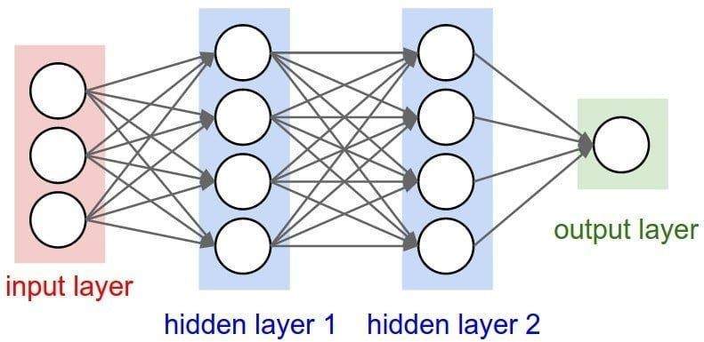

*Figure 13: Artificial Neural Network*

#### Learning Process in ANN:

ANNs learn by adjusting the weights and biases in the network through a process known as backpropagation. This is achieved via the following steps: In **Forward Propagation** input data passes through the network layers to make predictions. In **Loss Calculation** a loss function measures the error between the predicted output and the actual target. In **Backpropagation** the error is propagated backward, and the weights are updated using gradient descent to minimize the loss.

### Convolutional Neural Networks (CNNs):

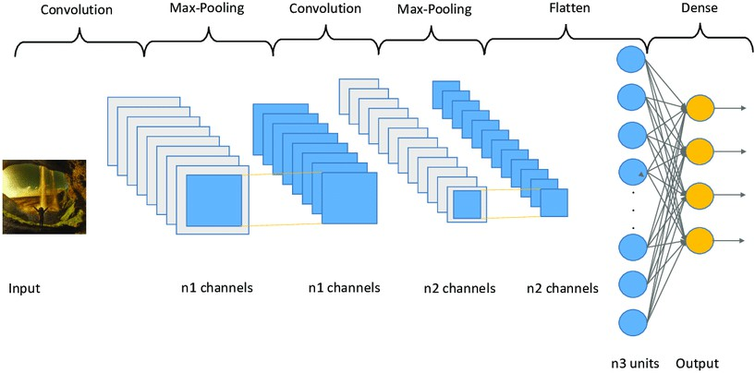

*Figure 14: Convolutional Neural Network*

A Convolutional Neural Network (CNN) is a specialized type of deep learning model designed to process and analyze grid-like data structures, such as images and videos. Unlike traditional neural networks, CNNs automatically and adaptively learn spatial hierarchies of features through layers of convolutional filters. These filters slide over the input data, detecting local patterns like edges, textures, and shapes, which are then combined to recognize more complex structures at deeper layers. This makes CNNs highly effective for tasks like image classification, object detection, and facial recognition. Additionally, CNNs use pooling layers to reduce the spatial dimensions of the data, minimizing computational complexity while preserving essential features. The architecture of CNNs allows them to excel in visual recognition tasks, making them a cornerstone in computer vision applications and a key driver of advancements in areas such as autonomous vehicles, medical imaging, and augmented reality.

#### CNN Architecture:

CNNs are composed of several types of layers that work together to transform an input image into a class label or other outputs. The key components of a typical CNN are:

* Input Layer
* Convolutional Layer
* Pooling Layer
* Fully Connected Layer
* Output Layer
  + - **Input Layer :** The input layer is the raw image itself, which is represented as a 3D matrix. For example, a coloured image is represented by a height (H), width (W), and depth (D = 3, for RGB channels).
    - **Convolutional Layer :** The convolutional layer is the heart of a CNN. It applies filters (kernels) to the input image, extracting features like edges and textures. Each filter slides over the image and performs element-wise multiplication, followed by summation, producing a feature map.
    - **Mathematics of Convolution :** If we have an input image matrix ***I*** and a filter (kernel) matrix ***K***, the convolution operation ***(I***∗***K)*** results in a feature map:

**FeatureMap[i,j] = Σm Σn I [i+m,j+n]*K[m,n] FeatureMap[i, j]**

Where: i,j are the spatial coordinates of the output feature map. m,n represent the kernel dimensions.

* + - **Pooling Layer:** The pooling layer reduces the dimensionality of the feature maps, making the network more computationally efficient and reducing overfitting. Pooling is typically done using two methods:
* **Max Pooling**: Takes the maximum value in each patch of the feature map.
* **Average Pooling**: Takes the average of all values in each patch.
  + - **Fully Connected Layer (FC Layer) :** The fully connected layer is a traditional neural network layer where each neuron is connected to every neuron in the previous layer. It flattens the 2D feature maps into a 1D vector to feed into the final decision layer. The output is a probability distribution across the possible classes.
    - **Output Layer:** The output layer typically uses a SoftMax activation function in classification tasks. This layer provides probabilities that the input image belongs to each

class. For example, if the network is classifying digits, the output could be a vector like [0.1, 0.9, 0.0, ...], indicating the probability of each class.

21 |

#### Working of a CNN (End-to-End Example):

**Step 1 - Input Image**: Suppose the input image is a 32x32x3 image.

**Step 2 - Convolution**: Apply convolution with a filter, which might reduce the spatial dimensions depending on the stride and padding used. For instance, a 3x3 filter with a stride of 1 on a 32x32 image will result in a 30x30 feature map.

**Step 3 - Activation**: The ReLU activation function is applied to add non-linearity to the model. **Step 4 - Pooling**: A 2x2 max pooling operation halves the spatial dimensions, resulting in a 15x15 feature map.

**Step 5 - Repeat**: More convolutional and pooling layers can be added to extract more complex features.

**Step 6 - Fully Connected Layer**: Flatten the feature maps and pass them through fully connected layers.

**Step 7 - Output**: The final layer provides class probabilities using softmax.

#### Transfer Learning:

Transfer learning is a machine learning technique where a pre-trained model, trained on a large dataset for a specific task, is reused for another related task. Instead of starting from scratch, transfer learning allows the model to use knowledge from one task to improve learning in a new task, especially when the target task has a smaller dataset.

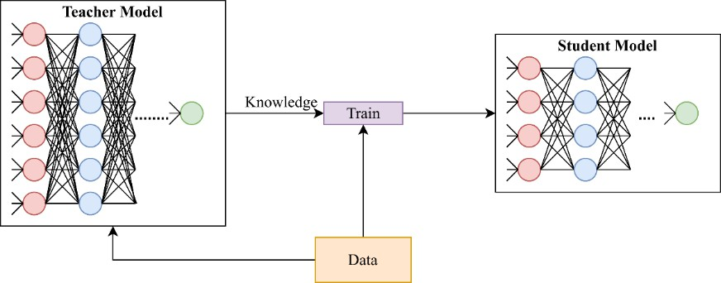

*Figure 15: Transfer Learning*

## Artificial Intelligence & Machine Learning Project:

**Face Recognition with Attendance System**

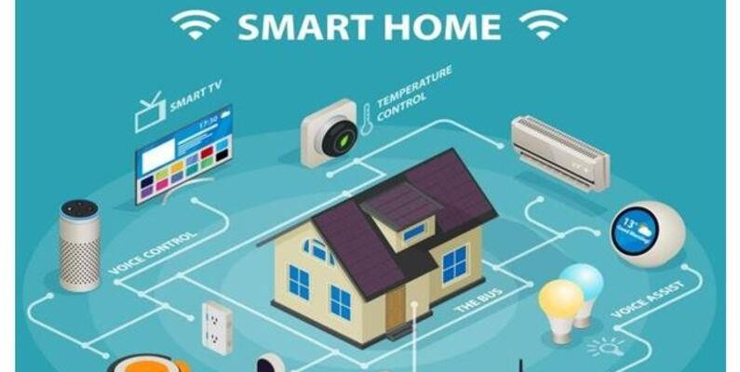

### About Dataset:

This dataset captures smart home device usage metrics, offering insights into user behavior, device efficiency, and preferences. It includes data on device types, usage patterns, energy consumption, malfunction incidents, and user satisfaction metrics.

**Features:**

* + - **UserID:** Unique identifier for each user.
    - **DeviceType:** Type of smart home device (e.g., Lights, Thermostat).
    - **UsageHoursPerDay:** Average hours per day the device is used.
    - **EnergyConsumption:** Daily energy consumption of the device (kWh).
    - **UserPreferences:** User preference for device usage (0 - Low, 1 - High).
    - **MalfunctionIncidents:** Number of malfunction incidents reported.
    - **DeviceAgeMonths:** Age of the device in months.
    - **SmartHomeEfficiency (Target Variable):** Efficiency status of the smart home device (0

- Inefficient, 1 - Efficient).

### The Project (Smart Home Efficiency Prediction)

#### Importing Different Python Libraries & The Data set:

*Figure 16: Importing Different Python Libraries & The Data set*

#### Check for null values:

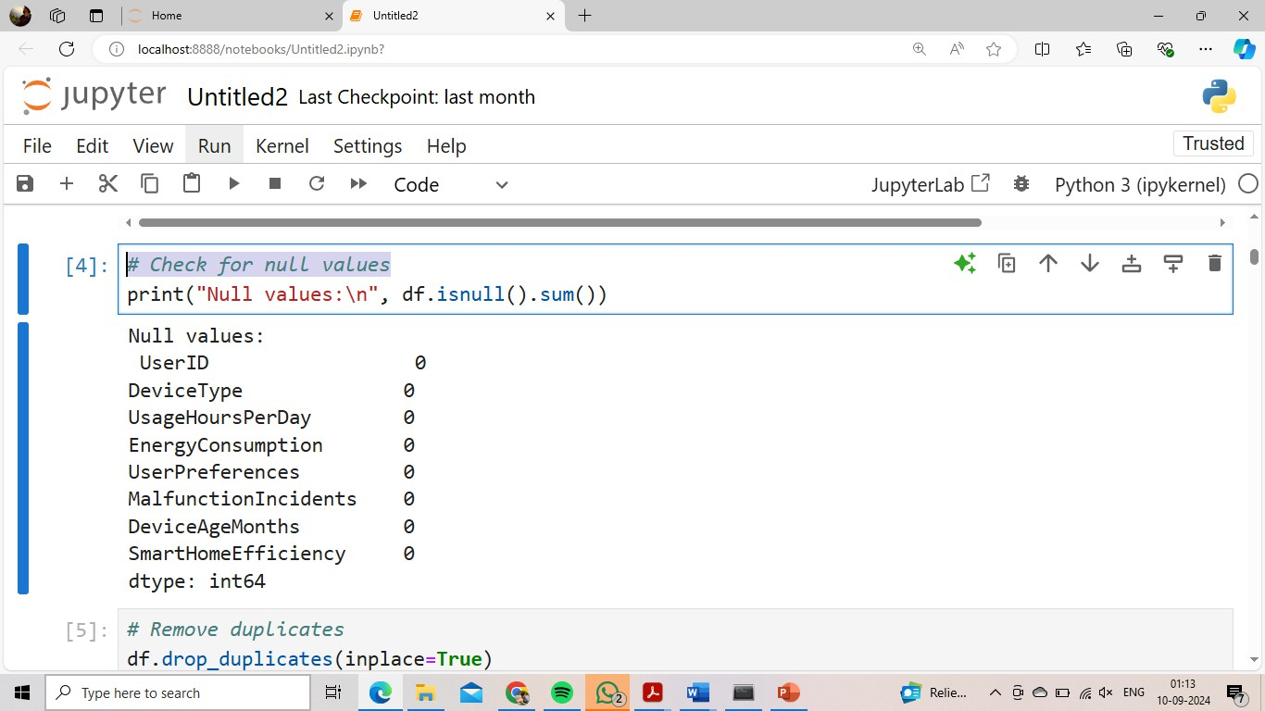

*Figure 17: Null Values*

#### Label Encoding:

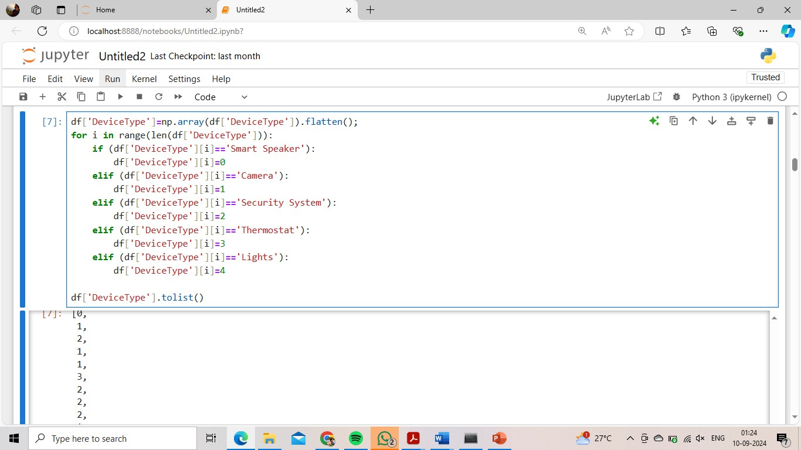

*Figure 18: Label Encoding*

#### Correlation matrix:

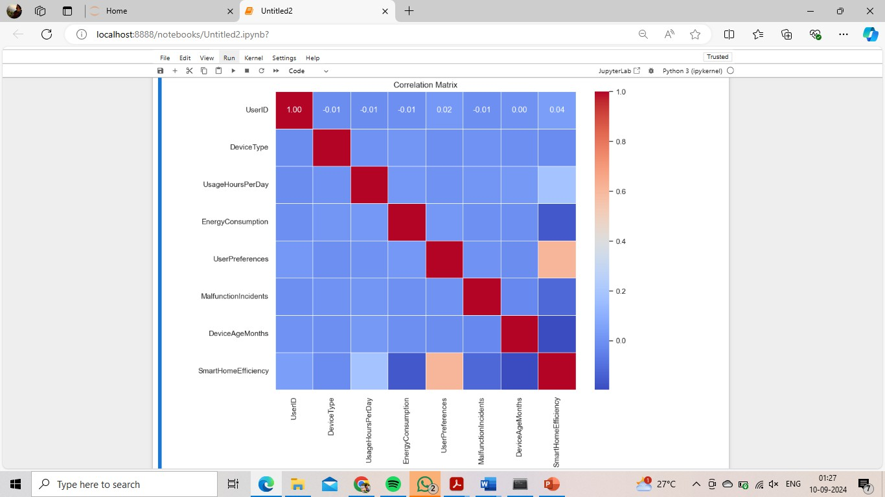

*Figure 19: Correlation Matrix*

#### Normalization (Z-Score Normalization):

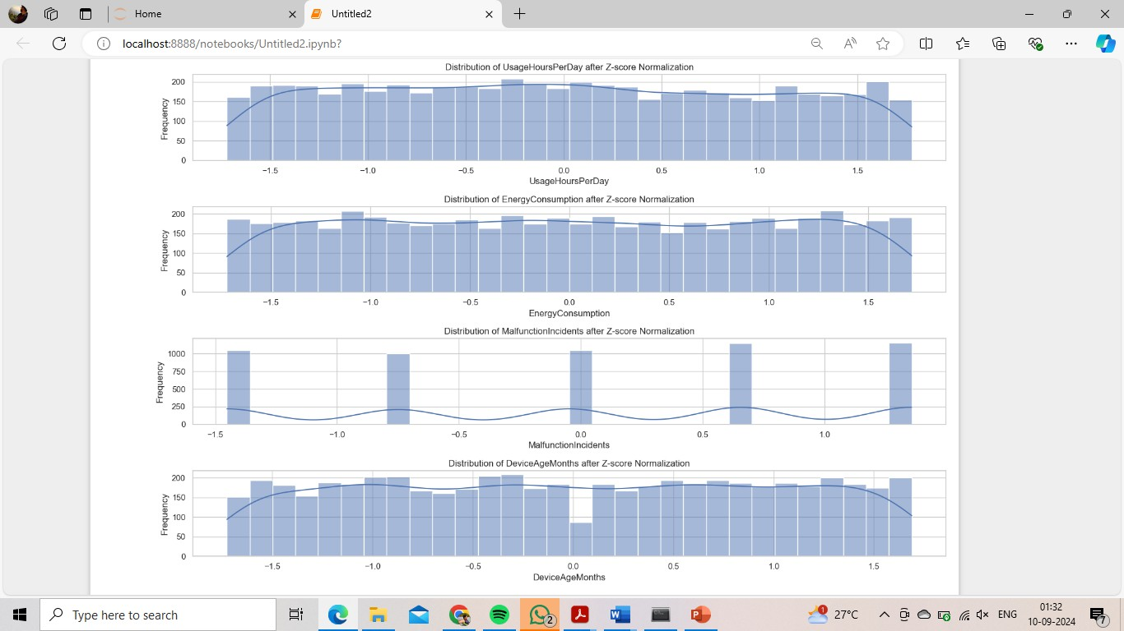

*Figure 20: Z-Score Normalization*

#### Prediction of Efficiency through Usage Hours vs Energy Consumption:

25 | P a g e

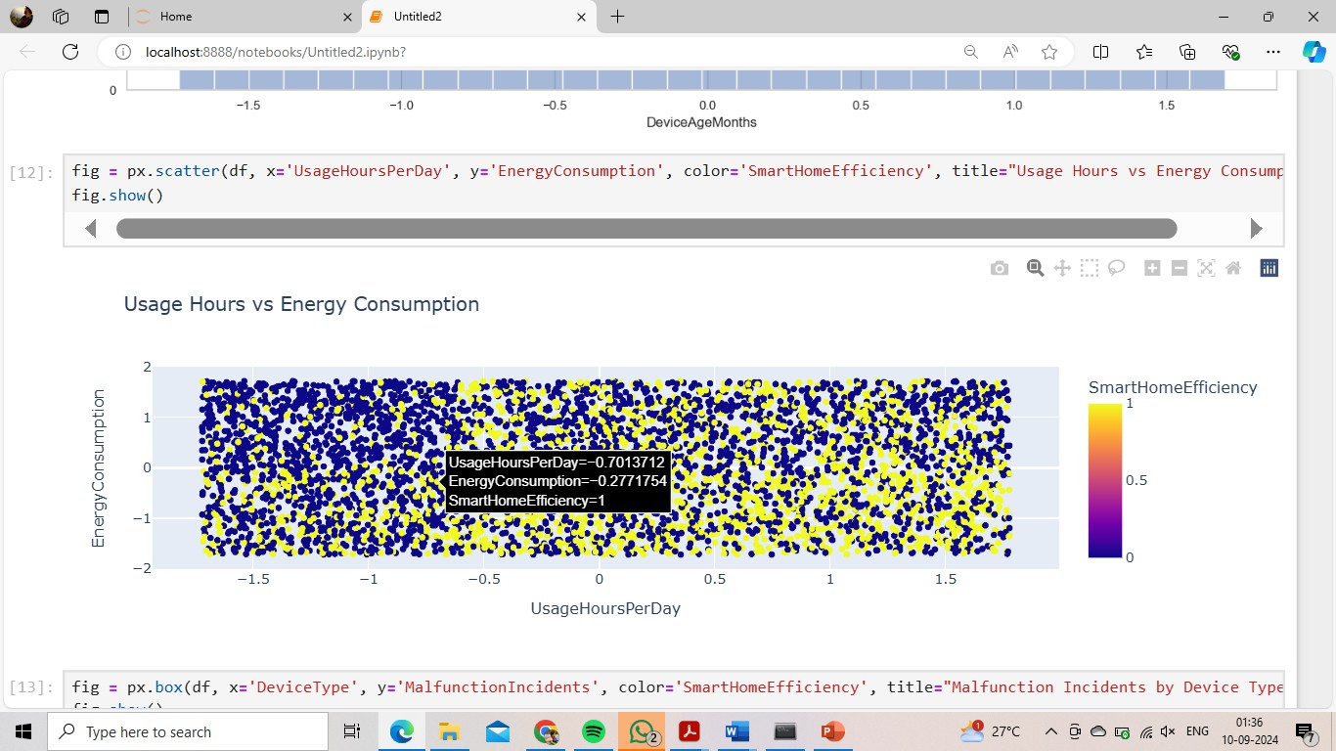

*Figure 21: Prediction of Efficiency through Usage Hours vs Energy Consumption*

#### Accuracy of different classification model:

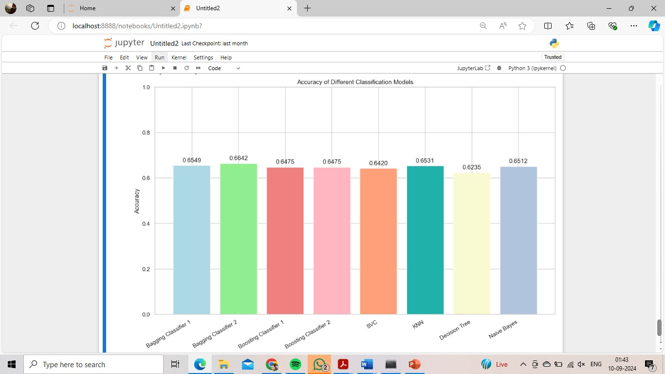

*Figure 22: Accuracy of different classification models*

### Future Work:

#### Model Improvement and Optimization:

* + Enhance predictive models for device failure, energy consumption, or user behavior by incorporating more sophisticated algorithms like deep learning or reinforcement learning.
  + Fine-tune existing models for better accuracy and generalization using hyperparameter tuning or additional feature engineering.

#### Real-time Data Processing:

* + Develop real-time analytics systems to monitor smart home devices and provide immediate feedback or alerts to users regarding malfunctions, energy usage, or unusual behaviour.
  + Implement edge computing for processing data directly on devices to reduce latency and improve real-time responsiveness.

#### Scalability and Deployment:

* + Scale the project to handle larger datasets, including data from a variety of different smart home ecosystems and devices.
  + Deploy the models and system into a real-world application, offering it as a service for smart home users or manufacturers to monitor device performance and user satisfaction.

#### User Interface and Experience Enhancement:

* + Build intuitive dashboards or mobile apps that allow users to visualize data on their device usage, energy consumption, and satisfaction in a user-friendly manner.
  + Integrate voice assistant functionality or notifications for proactive suggestions based on user behaviour and device efficiency.

### Conclusion:

This project provides valuable insights into smart home device usage patterns and efficiency, supporting analysis on factors influencing user satisfaction and device performance.

## Advantages:

Machine Learning (ML) and Deep Learning (DL) offer several advantages that make them powerful tools in modern technology:

### Automation:

ML and DL models can automate complex tasks, reducing the need for manual intervention and increasing efficiency in areas like data analysis, customer service, and decision-making.

### Accuracy:

Deep learning models, in particular, can achieve high levels of accuracy by learning from large datasets, making them ideal for tasks like image and speech recognition.

### Scalability:

Both ML and DL can handle vast amounts of data, making them scalable solutions for businesses that need to process and analyze large datasets.

### Adaptability:

ML models can learn and improve over time, adapting to new data and evolving conditions, which is crucial for applications like personalized recommendations and predictive maintenance.

### Complex Problem Solving:

Deep learning excels at solving highly complex problems, such as natural language processing and autonomous driving, where traditional algorithms may fall short.

### Data-Driven Decisions:

ML and DL enable data-driven decision-making by uncovering insights and patterns that may not be immediately obvious, leading to more informed and strategic choices.

## Disadvantages:

### Data Dependency:

* + **Large Amounts of Data Required:** ML models often require large datasets to train effectively. High-quality data is essential for accurate predictions, and acquiring or generating sufficient data can be challenging.
  + **Data Quality Issues:** Poor quality data, including missing, noisy, or biased data, can lead to inaccurate models and unreliable predictions. Ensuring data cleanliness and relevance is crucial but can be difficult.

### Complexity and Interpretability:

* + **Complex Model Structures:** ML models, especially complex ones like deep neural networks, can be difficult to understand and troubleshoot, making it challenging to identify the cause of errors or biases.

### Overfitting and Underfitting:

* + **Overfitting:** ML models can overfit to the training data, meaning they perform exceptionally well on the data they were trained on but poorly on new, unseen data. This typically happens when the model learns the noise and details in the training data rather than generalizing from it.
  + **Underfitting:** Conversely, underfitting occurs when the model is too simplistic to capture the underlying patterns in the data, leading to poor performance on both training and test data.

### Dependency on Feature Engineering

* + **Manual Feature Engineering:** Although some ML models, especially deep learning models, can perform automatic feature extraction, many traditional ML models require manual feature engineering. This process can be time-consuming and requires domain expertise.
  + **Feature Selection Challenges:** Selecting the right features and reducing dimensionality can be complex and requires a deep understanding of the data and the problem domain.

# CONCLUSION:

ML and DL represent a continuum of methods for solving complex problems. While ML provides a broad set of tools and techniques for various applications, DL offers advanced capabilities for handling intricate patterns and large-scale data. Together, they form a comprehensive toolkit for modern data science. Continuous research is essential for addressing current limitations, improving model performance, and exploring new applications. Collaboration across disciplines and industries will facilitate the advancement of ML and DL technologies and their integration into real-world solutions. Both ML and DL have significant ethical implications, including issues related to data privacy, fairness, and accountability. Ensuring responsible use and addressing biases in models are crucial for maintaining public trust and achieving equitable outcomes. In summary, Machine Learning and Deep Learning are highly impactful technologies that have revolutionized various industries by facilitating data-driven decision-making and automation. Both methods offer significant advantages, though they also present certain challenges. The future promises vast potential for progress and innovation through their combined use. To fully realize their benefits, it will be crucial to address ethical issues, enhance model performance, and explore new possibilities, ensuring their responsible and effective implementation.

# REFERENCES

1. Cerulli, G., 2023. Fundamentals of Supervised Machine Learning: With Applications in Python, R, and Stata. Springer Nature.
2. Shalev-Shwartz, S. and Ben-David, S., 2014. Understanding machine learning: From theory to algorithms. Cambridge university press.
3. Sarker, I.H., 2021. Machine learning: Algorithms, real-world applications and research directions. SN computer science, 2(3), p.160.
4. Russell, S.J. and Norvig, P., 2016. Artificial intelligence: a modern approach. Pearson.
5. James, Gareth. "An introduction to statistical learning." (2013).LeCun, Y., Bengio, Y. and Hinton, G., 2015. Deep learning. nature, 521(7553), pp.436-444.